**WITH NOISE AND WITH FILTER FUZZY**

**Image set:**

|  |
| --- |
| **Image 1:-0.1 % Noise** |

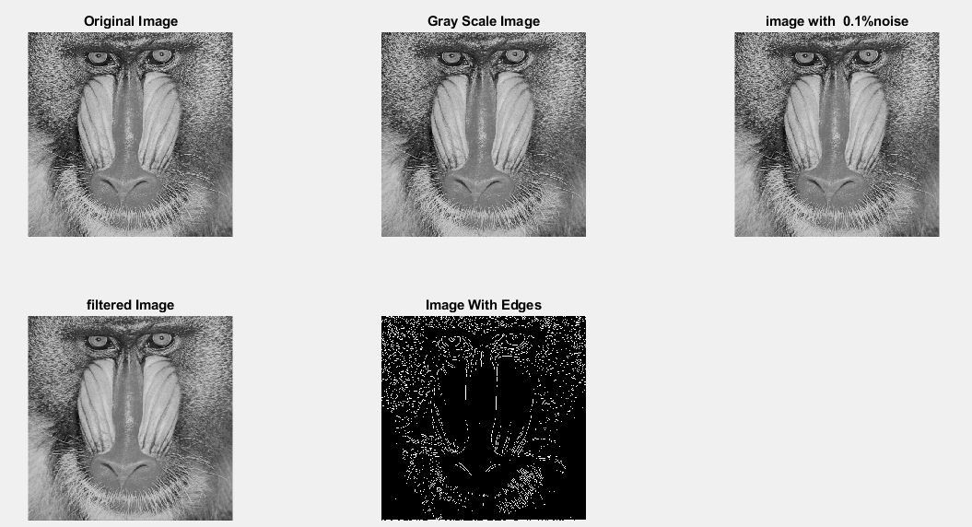

**Image 2:-10 % Noise**

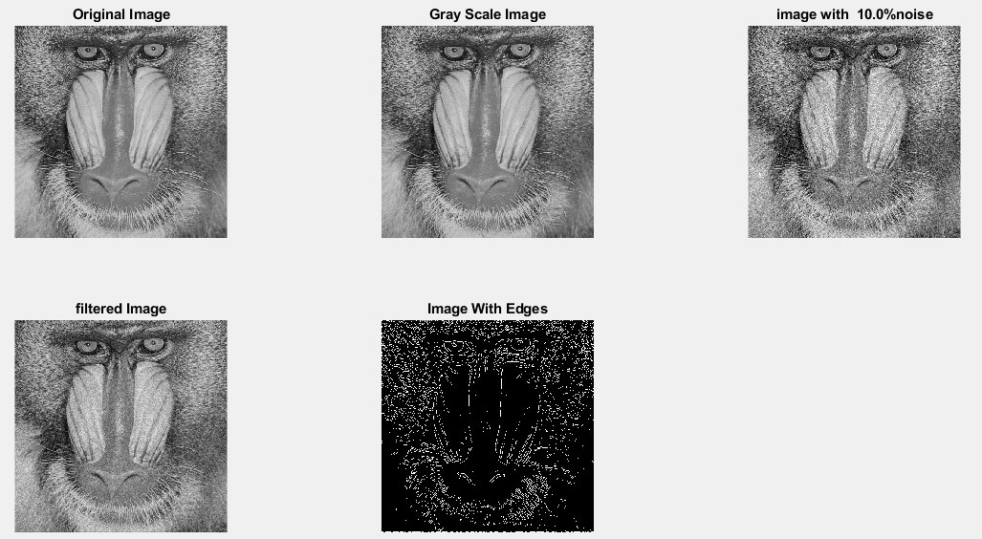

**Image 3:-20 % Noise**

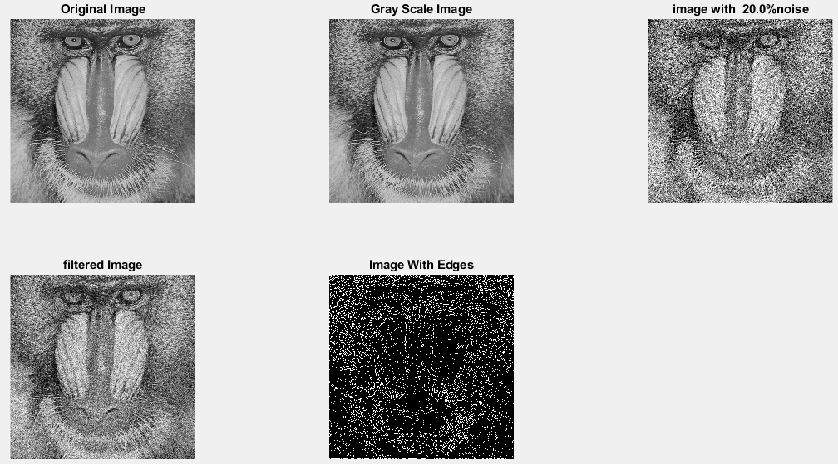

**Image 4:-30 % Noise**

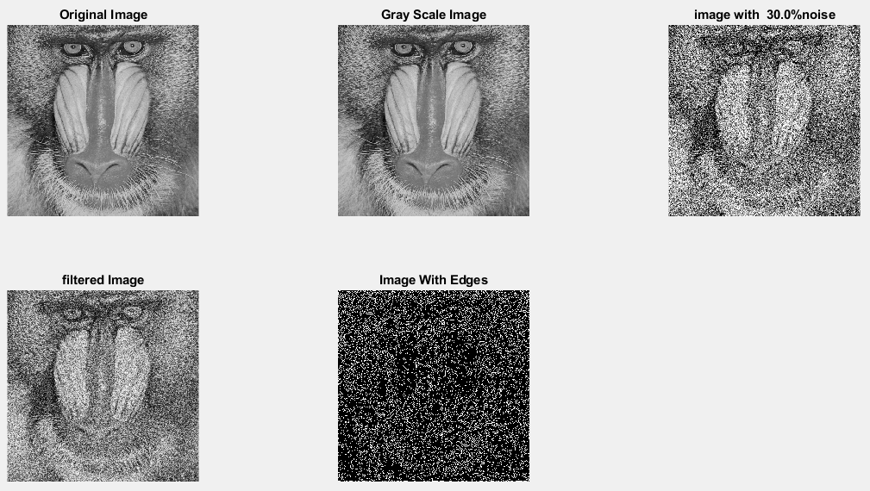

|  |
| --- |
| **Image 5:-40 % Noise** |

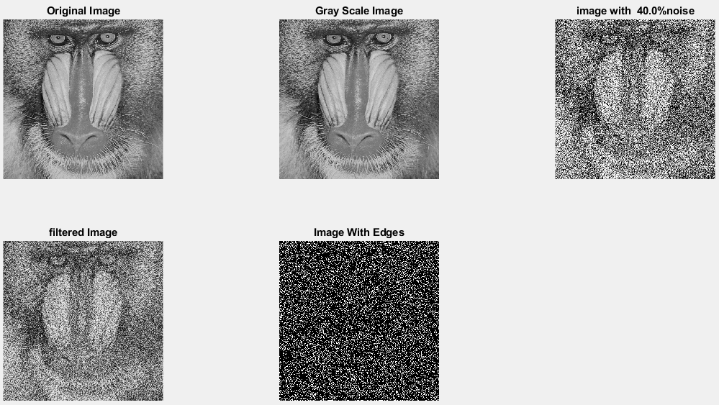

**Image 6:-50 % Noise**



**Image 7:-60 % Noise**

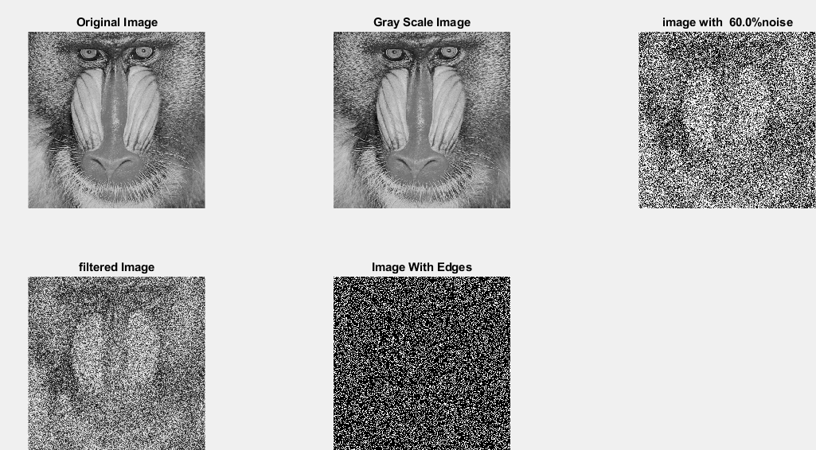

**Image 8:-70 % Noise**

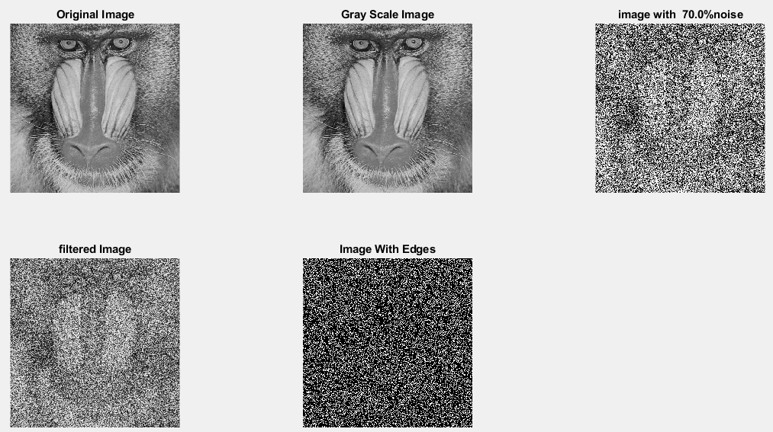

**Image 9:-80 % Noise**

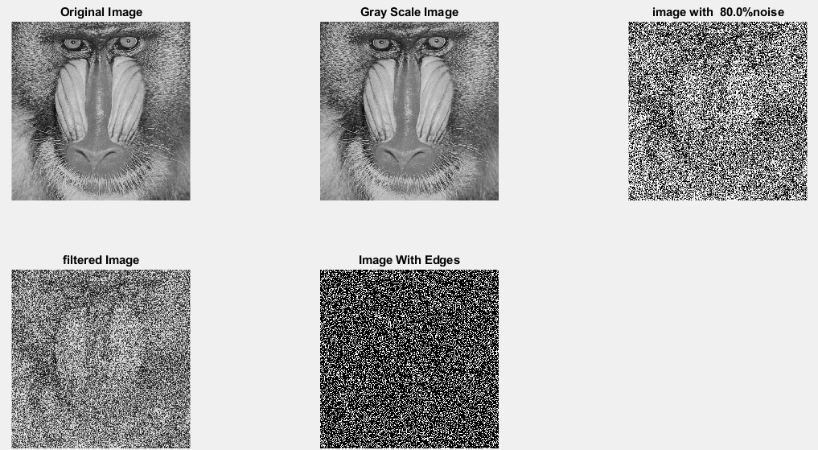

**DATA FILES**

**Image 1:-Noise0.1**

Original image ideal values:

IM1 image entropy:3.527597e-01

IM1 image mean:0.066509

Ground truth image entropy:0.943520

Ground truth image mean:0.361012

entropy between imt and im1 :0.918088

MSE between imt and im1 :0.371750

Average Difference between imt and im1 :0.294502

Maximum Difference between imt and im1 :1.000000

True Positive values:7310.000000

False Positive values: 10125.000000

True Negative values:157382.000000

False Negative values:87327.000000

Accuracy value: 0.628250

F Measure values:0.130452

Peak Signal-to Noise Ration value: 4.297492

Signal-to Noise Ration value: -7.346390

percentage of pixels that were correctly detected (Pco): 0.077243

The percentage of pixels that were not detected (Pnd):0.922757

the percentage of false alarm: (Pfa):0.106988

Euclidean Distance Value :6.851488

**Image 2:-Noise10**

Original image ideal values:

IM1 image entropy:4.056975e-01

IM1 image mean:0.081001

Ground truth image entropy:0.943520

Ground truth image mean:0.361012

entropy between imt and im1 :0.911724

MSE between imt and im1 :0.373783

Average Difference between imt and im1 :0.280010

Maximum Difference between imt and im1 :1.000000

True Positive values:8943.000000

False Positive values: 12291.000000

True Negative values:155216.000000

False Negative values:85694.000000

Accuracy value: 0.626217

F Measure values:0.154361

Peak Signal-to Noise Ration value: 4.273803

Signal-to Noise Ration value: -6.490292

percentage of pixels that were correctly detected (Pco): 0.094498

The percentage of pixels that were not detected (Pnd):0.905502

the percentage of false alarm: (Pfa):0.129875

Euclidean Distance Value :8.548214

**Image 3:-Noise20**

Original image ideal values:

IM1 image entropy:5.479710e-01

IM1 image mean:0.126575

Ground truth image entropy:0.943520

Ground truth image mean:0.361012

entropy between imt and im1 :0.894295

MSE between imt and im1 :0.387512

Average Difference between imt and im1 :0.234436

Maximum Difference between imt and im1 :1.000000

True Positive values:13117.000000

False Positive values: 20064.000000

True Negative values:147443.000000

False Negative values:81520.000000

Accuracy value: 0.612488

F Measure values:0.205245

Peak Signal-to Noise Ration value: 4.117146

Signal-to Noise Ration value: -4.551715

percentage of pixels that were correctly detected (Pco): 0.138603

The percentage of pixels that were not detected (Pnd):0.861397

the percentage of false alarm: (Pfa):0.212010

Euclidean Distance Value :12.920594

**Image 4:-Noise30**

Original image ideal values:

IM1 image entropy:6.905049e-01

IM1 image mean:0.184818

Ground truth image entropy:0.943520

Ground truth image mean:0.361012

entropy between imt and im1 :0.870710

MSE between imt and im1 :0.406898

Average Difference between imt and im1 :0.176193

Maximum Difference between imt and im1 :1.000000

True Positive values:18210.000000

False Positive values: 30239.000000

True Negative values:137268.000000

False Negative values:76427.000000

Accuracy value: 0.593102

F Measure values:0.254532

Peak Signal-to Noise Ration value: 3.905139

Signal-to Noise Ration value: -2.907761

percentage of pixels that were correctly detected (Pco): 0.192419

The percentage of pixels that were not detected (Pnd):0.807581

the percentage of false alarm: (Pfa):0.319526

Euclidean Distance Value :18.281208

**Image 5:-Noise40**

Original image ideal values:

IM1 image entropy:7.640306e-01

IM1 image mean:0.222126

Ground truth image entropy:0.943520

Ground truth image mean:0.361012

entropy between imt and im1 :0.853869

MSE between imt and im1 :0.418800

Average Difference between imt and im1 :0.138885

Maximum Difference between imt and im1 :1.000000

True Positive values:21540.000000

False Positive values: 36689.000000

True Negative values:130818.000000

False Negative values:73097.000000

Accuracy value: 0.581200

F Measure values:0.281815

Peak Signal-to Noise Ration value: 3.779930

Signal-to Noise Ration value: -2.109216

percentage of pixels that were correctly detected (Pco): 0.227607

The percentage of pixels that were not detected (Pnd):0.772393

the percentage of false alarm: (Pfa):0.387681

Euclidean Distance Value :21.792461

**Image 6:-Noise50**

Original image ideal values:

IM1 image entropy:7.992738e-01

IM1 image mean:0.242561

Ground truth image entropy:0.943520

Ground truth image mean:0.361012

entropy between imt and im1 :0.845120

MSE between imt and im1 :0.426678

Average Difference between imt and im1 :0.118450

Maximum Difference between imt and im1 :1.000000

True Positive values:23186.000000

False Positive values: 40400.000000

True Negative values:127107.000000

False Negative values:71451.000000

Accuracy value: 0.573322

F Measure values:0.293080

Peak Signal-to Noise Ration value: 3.699001

Signal-to Noise Ration value: -1.726995

percentage of pixels that were correctly detected (Pco): 0.244999

The percentage of pixels that were not detected (Pnd):0.755001

the percentage of false alarm: (Pfa):0.426894

Euclidean Distance Value :23.529008

**Image 7:-Noise60**

Original image ideal values:

IM1 image entropy:8.263406e-01

IM1 image mean:0.259731

Ground truth image entropy:0.943520

Ground truth image mean:0.361012

entropy between imt and im1 :0.836996

MSE between imt and im1 :0.432541

Average Difference between imt and im1 :0.101280

Maximum Difference between imt and im1 :1.000000

True Positive values:24668.000000

False Positive values: 43419.000000

True Negative values:124088.000000

False Negative values:69969.000000

Accuracy value: 0.567459

F Measure values:0.303188

Peak Signal-to Noise Ration value: 3.639728

Signal-to Noise Ration value: -1.429968

percentage of pixels that were correctly detected (Pco): 0.260659

The percentage of pixels that were not detected (Pnd):0.739341

the percentage of false alarm: (Pfa):0.458795

Euclidean Distance Value :25.092867

**Image 8:-Noise70**

Original image ideal values:

IM1 image entropy:8.429012e-01

IM1 image mean:0.271004

Ground truth image entropy:0.943520

Ground truth image mean:0.361012

entropy between imt and im1 :0.830195

MSE between imt and im1 :0.434589

Average Difference between imt and im1 :0.090008

Maximum Difference between imt and im1 :1.000000

True Positive values:25877.000000

False Positive values: 45165.000000

True Negative values:122342.000000

False Negative values:68760.000000

Accuracy value: 0.565411

F Measure values:0.312375

Peak Signal-to Noise Ration value: 3.619209

Signal-to Noise Ration value: -1.245458

percentage of pixels that were correctly detected (Pco): 0.273434

The percentage of pixels that were not detected (Pnd):0.726566

the percentage of false alarm: (Pfa):0.477245

Euclidean Distance Value :26.368739

**Image 9:-Noise80**

Original image ideal values:

IM1 image entropy:8.509246e-01

IM1 image mean:0.276707

Ground truth image entropy:0.943520

Ground truth image mean:0.361012

entropy between imt and im1 :0.827572

MSE between imt and im1 :0.436790

Average Difference between imt and im1 :0.084305

Maximum Difference between imt and im1 :1.000000

True Positive values:26336.000000

False Positive values: 46201.000000

True Negative values:121306.000000

False Negative values:68301.000000

Accuracy value: 0.563210

F Measure values:0.315073

Peak Signal-to Noise Ration value: 3.597268

Signal-to Noise Ration value: -1.155014

percentage of pixels that were correctly detected (Pco): 0.278284

The percentage of pixels that were not detected (Pnd):0.721716

the percentage of false alarm: (Pfa):0.488192

Euclidean Distance Value :26.853245